MGMT 6128 PROJECT MANAGEMENT · MIDTERM PRACTICE CASE
Campus Charity 5K Run
Model answer: Gantt chart, resources and stakeholder communication plans
This is a fictional practice case written for midterm revision. It is not an official exam. Durations, dates and costs are illustrative. The answer is written from the point of view of an experienced PMP project manager. It is structured against the exam’s mark scheme: Question 1 (50 marks), Question 2 (10 marks) and Question 3 (20 marks).
AI use: this practice case and model answer were generated with an AI assistant. See the AI use disclosure at the end of the document.
Companion file: Charity 5K - Model Answer.xml. Open it in MS Project with File → Open, set the file type to XML Format, and choose “As a new project”. Appendix A explains the settings to check.

Schedule at a glance
Item | Value
Project start | Mon Feb 1, 2027
Race day (deadline) | Fri Apr 16, 2027
Project finish | Wed Apr 28, 2027
Duration | 61 working days (about 3 months). Standard Monday–Friday calendar, 8:00–17:00, with Family Day (Mon Feb 15) and Good Friday (Fri Mar 26) set as non-working days (Government of Ontario, n.d.).
Activities | 40 activities and 5 milestones under 8 level-1 summary tasks
Resources | 5 work resources, 1,320 hours of planned work, no overallocation
Critical path | 21 tasks and milestones, from the kickoff meeting to project close

Question 1: Gantt chart (50 marks)
The Gantt chart covers every deliverable in the case, with 40 activities and 5 milestones. WBS codes sit in the first column, durations reflect the real work and the waiting time around it, every activity is logically linked, and the critical path is highlighted in red.

Scope areas mapped to the WBS
Each of the case’s eight scope areas is a level-1 summary task, and every listed deliverable appears as at least one activity. Overall Project Management is placed first, as WBS 1, following common practice. Its summary bar therefore spans the whole project, from kickoff to close.
Case scope area | WBS | Deliverables and the activities that produce them
1. Route & Permits | 2 | Measured route map (2.1); approved permits (2.2–2.4, milestone 2.6); safety and emergency plan (2.5)
2. Registration & Fundraising | 3 | Registration form with fees and waiver (3.1, 3.2, 3.4); fundraising pages (3.3); registration deadline and participant list (3.6)
3. Sponsorship | 4 | Sponsorship package and tiers (4.1); signed agreements (4.2, 4.3); sponsor recognition (4.4, 8.3)
4. Marketing Campaign | 5 | Promotional materials (5.2); social media and campus outreach plan (5.1, 5.3, 5.5); team challenge (5.4)
5. Volunteers | 6 | Volunteer roles and schedule (6.1–6.3); training and briefing (6.4)
6. Race Kit & Logistics | 7 | Vendor contracts (7.1, 7.2); race kits with bib, chip and T-shirt (7.3, 7.4, 7.6); water stations, barriers, signage and first aid (7.5)
7. Race Day | 8 | Race-kit pick-up (8.1); course set-up and teardown (8.2, 8.5); timed results and awards (8.3, 8.6)
8. Overall Project Management | 1 | Charter and plan (1.1–1.4); donation hand-over (1.5); feedback survey, final report and lessons learned (1.6–1.8)

(a) WBS codes (5 marks)
- The WBS column is inserted as the first column of the Entry table (right-click the first column heading → Insert Column → WBS; Microsoft, n.d.-b).
- Level 1 holds the eight scope areas (1–8). Level 2 holds the activities and milestones (for example 2.4, 3.5). The codes follow the outline, so a reader can trace any bar back to its deliverable.
- Appendix B lists every row with its ID, WBS code, duration, dates, predecessors, resources and slack.
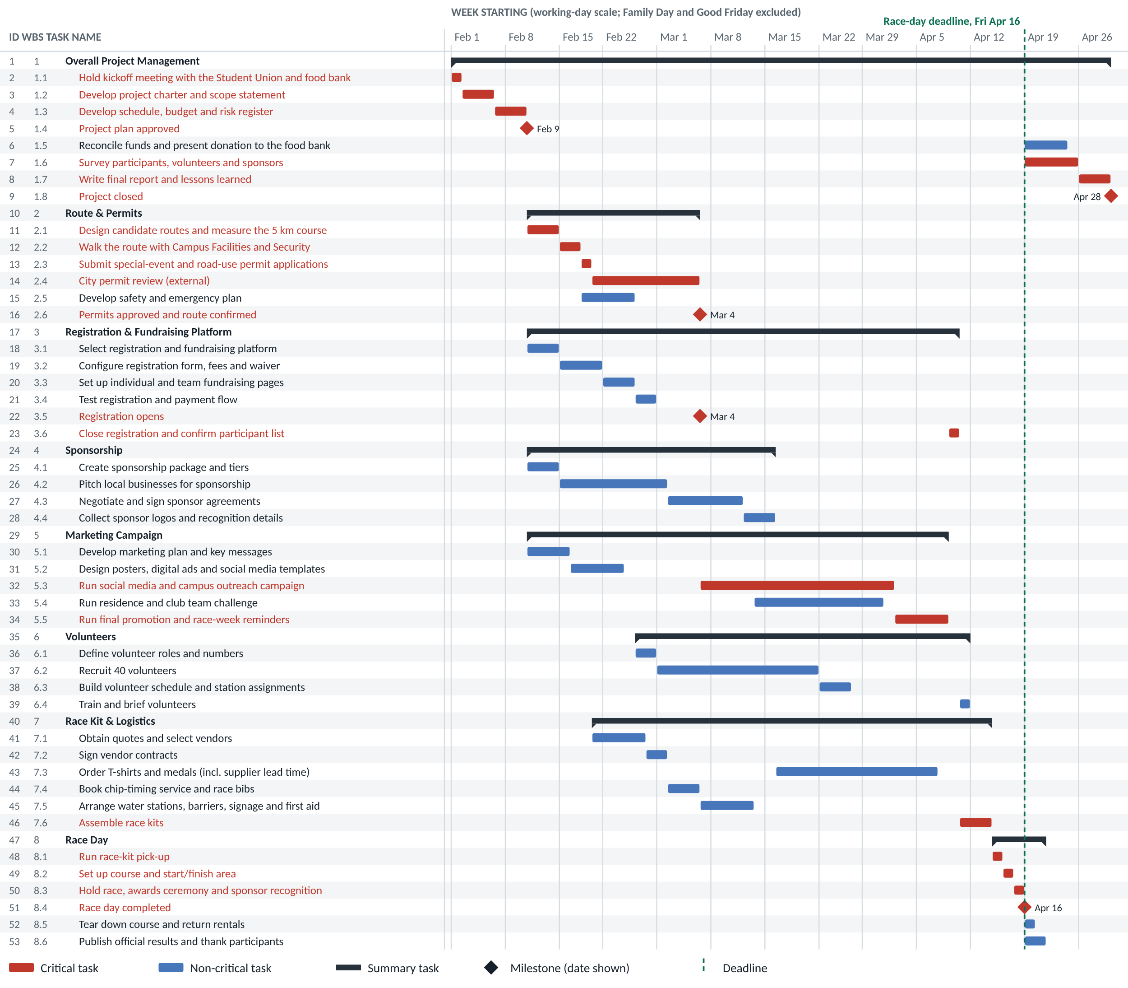
Figure 1. Gantt chart exported from the model schedule. Red bars are on the critical path, diamonds are milestones and the dashed line marks the race-day deadline.

(b) Durations (10 marks)
Durations are in working days and are sized to the effort and the waiting each step really involves. Milestones are 0 days. The estimates that drive the schedule are:
WBS | Activity | Duration | Basis of estimate
2.4 | City permit review (external) | 10d | Assumed review period after a complete application. No team resource, because the work sits with the city.
4.2 | Pitch local businesses for sponsorship | 10d | About two weeks of outreach calls and meetings with 15–20 businesses
5.3 | Run social media and campus outreach campaign | 18d | Runs from registration opening to the start of race-week reminders
5.4 | Run residence and club team challenge | 12d | Starts in week 2 of the campaign and ends before the final push
6.2 | Recruit 40 volunteers | 15d | Three weeks of recruiting through clubs, residences and classes
7.3 | Order T-shirts and medals | 15d | Mostly supplier production and delivery lead time for custom printing
8.1–8.3 | Race-week tasks | 1d each | Kit pick-up, course set-up and race day run on consecutive days
Milestones | 1.4, 1.8, 2.6, 3.5, 8.4 | 0d | Points in time that mark approvals and completions

(c) Logical links (10 marks)
Every activity has at least one predecessor and one successor. The only exceptions are the kickoff, which starts the project, and the final milestone, which ends it. No summary task is linked, and no start dates are typed in, so the logic alone drives the dates. The race-day deadline is a marker only and does not move any task. The links that carry the most logic are:
Link (WBS) | Type | Why
1.4 → 2.1, 3.1, 4.1, 5.1 | Finish-to-start | No work is committed or spent until the Student Union approves the plan.
2.6 → 3.5 | Finish-to-start | Registration cannot open, and fees cannot be taken, until the route is approved.
5.2 → 3.5 | Finish-to-start | Promotional material must be ready when registration launches.
5.3 → 5.4 | Start-to-start + 5d | The team challenge starts in week 2 of the campaign, once momentum is built.
4.4 → 7.3 | Finish-to-start | Sponsor logos are printed on the T-shirts, so the order waits for the logos.
3.6 → 6.4, 7.6 | Finish-to-start | Volunteer stations and kits are planned against the final participant count.
8.4 → 1.5, 1.6, 8.6 | Finish-to-start | Close-out work starts once race day is complete.

(d) Critical path (5 marks)
In MS Project the critical path is shown in red by ticking Critical Tasks on the Format tab (Microsoft, n.d.-c). It runs for 61 working days, unbroken from the kickoff to project close:
1.1 → 1.2 → 1.3 → 1.4 → 2.1 → 2.2 → 2.3 → 2.4 → 2.6 → 3.5 → 5.3 → 5.5 → 3.6 → 7.6 → 8.1 → 8.2 → 8.3 → 8.4 → 1.6 → 1.7 → 1.8
In plain terms: plan approval → route design and the city permit review → registration opens → outreach campaign and final promotion → registration closes → race kits assembled → race week → feedback survey and final report → project closed.
What this means for the project manager. The city permit review is the main schedule risk, because each day it slips moves race day. The communication plan in Question 3 targets it directly. Several paths have very little slack and need watching:
WBS | Near-critical work | Total slack | Watch for
7.3 | Order T-shirts and medals | 2 days | Late sponsor logos (4.4)
4.1–4.4 | Sponsorship chain | 2 days | Slow sponsor sign-off
6.4 | Train and brief volunteers | 2 days | Registration closing late
1.5 | Reconcile funds and present donation | 1 day | Late pledge payments
5.4 | Run residence and club team challenge | 1 day | Late start to the challenge

Milestones
WBS | Milestone | Date
1.4 | Project plan approved | Tue Feb 9, 2027
2.6 | Permits approved and route confirmed | Thu Mar 4, 2027
3.5 | Registration opens | Thu Mar 4, 2027
8.4 | Race day completed | Fri Apr 16, 2027
1.8 | Project closed | Wed Apr 28, 2027

Question 2: Human resources (10 marks)

(a) Resource Sheet (5 marks)
Five work resources are set up in View → Resource Sheet. Each has a clear role, and together they cover every scope area. All five are in the “Core team” group with maximum units of 100%.
Resource name | Initials | Type | Main responsibilities | Planned work
Project Manager | PM | Work | Plans and controls the project, leads sponsor relationships, reports to the Student Union, closes the project | 304 h
Event Logistics Coordinator | ELC | Work | Route design, permit paperwork, vendors, race kits, course set-up and teardown | 224 h
Marketing & Communications Coordinator | MKT | Work | Marketing plan, creative, social media campaign, feedback survey | 304 h
Registration & Technology Coordinator | RTC | Work | Registration and fundraising platform, team challenge, chip timing, results | 232 h
Volunteer & Safety Coordinator | VSC | Work | Safety and emergency plan, volunteer recruiting, scheduling and training | 256 h

(b) Assignments (5 marks)
Resources are assigned with Resource → Assign Resources (Alt+F10). The matrix below shows which activities each person works on. Appendix B gives the assignment on every row.
WBS area | PM | ELC | MKT | RTC | VSC
1 Overall Project Management | 1.1, 1.2, 1.3, 1.5, 1.7 | – | 1.6 | – | –
2 Route & Permits | – | 2.1, 2.2, 2.3 | – | – | 2.2, 2.5
3 Registration & Fundraising Platform | – | – | – | 3.1, 3.2, 3.3, 3.4, 3.6 | –
4 Sponsorship | 4.1, 4.2, 4.3, 4.4 | – | – | – | –
5 Marketing Campaign | – | – | 5.1, 5.2, 5.3, 5.5 | 5.4 | –
6 Volunteers | – | – | – | – | 6.1, 6.2, 6.3, 6.4
7 Race Kit & Logistics | – | 7.1, 7.2, 7.3, 7.5, 7.6 | – | 7.4, 7.6 | –
8 Race Day | 8.3 | 8.1, 8.2, 8.3, 8.5 | 8.3 | 8.1, 8.3, 8.6 | 8.1, 8.2, 8.3, 8.5

- Every activity has an owner. Milestones and the city’s permit review (2.4) have no resource. A milestone has no work, and the review is done by people outside the team.
- Partial units where the work is light. The ELC is at 20% on the T-shirt order (7.3) because most of that time is supplier lead time. The RTC is at 50% on the team challenge (5.4), which runs alongside other work.
- No overallocation. The Resource Usage view shows nobody above 100% on any day. Race day (8.3) is the only task that uses all five people.
- Durations stay fixed. Tasks are set to Fixed Duration and are not effort-driven, so adding a second person to a task (for example 2.2 or 8.2) does not shorten it.
- PM owns the sponsor relationship. Sponsors are high-power stakeholders, so the PM leads 4.1–4.4 personally rather than delegating it.

Question 3: Stakeholders (20 marks)

(a) Six stakeholders (6 marks)
Stakeholder | Role and interest in the project | Power | Interest | Approach
Student Union executive | Project sponsor. Funds the event, owns the brand and approves the plan. Wants a safe, well-attended race delivered on budget. | High | High | Manage closely
Campus Facilities & Security | Approves the on-campus route, venue use and safety plan. Can stop the event on safety grounds. | High | Medium | Keep satisfied
City special-events office | Issues the road-use permit and sets its conditions, such as traffic control, insurance and paid-duty police. | High | Low | Keep satisfied
Corporate sponsors | Local businesses that pay for shirts, medals, water and prizes in return for visibility. | High | High | Manage closely
Student Food Bank | The beneficiary. Wants the most money and awareness possible, and supplies stories for the marketing. | Low | High | Keep informed
Participants | Students, staff and community runners. They register, raise pledges and judge whether the event succeeded. | Medium | High | Keep informed
Other stakeholders worth naming in a fuller register include volunteers, vendors, the timing company, neighbours along the route and campus media.
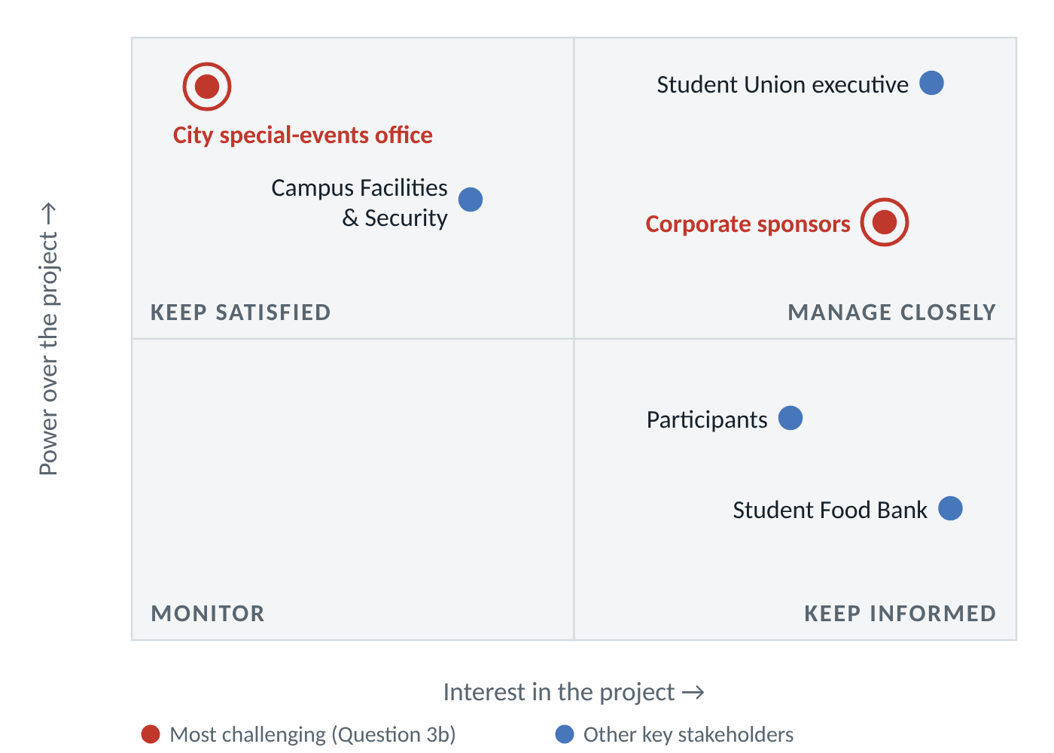
Figure 2. Power/interest grid, after PMI (2017). The two most challenging stakeholders are ringed in red.

(b) The two most challenging stakeholders (6 marks)

1. City special-events office
- High power, low interest. The office can refuse, delay or attach conditions to the permit, and our race date is not its priority.
- On the critical path. The 10-day review (2.4) is critical. Registration cannot open until the permit is approved (2.6 → 3.5), so every day of delay moves race day.
- No authority over it. The team cannot direct the city. Late conditions, such as a traffic-control plan, paid-duty officers or a higher insurance limit, add cost and rework close to launch.

2. Corporate sponsors
- High power, high interest. Sponsors fund a large share of the race costs, and each expects a visible return.
- Competing demands. Several sponsors push on logo size, placement and exclusivity, and those demands can clash with the college’s brand rules.
- Schedule and budget risk. Late logo approvals hold up the T-shirt order (7.3), which has only 2 days of slack. A sponsor that withdraws leaves a budget gap close to race day.

(c) Communication plans (8 marks)
Both plans follow the same structure: a goal, a named owner, a target engagement level, and a schedule of communications. Each communication is tagged with the communication method it uses (push, pull or interactive; PMI, 2017), its format and its timing, and each plan ends with feedback and escalation routes.

Engagement assessment
Stakeholder | Unaware | Resistant | Neutral | Supportive | Leading
City special-events office |  |  | C | D
Corporate sponsors |  |  |  | C | D
C = current engagement, D = desired engagement. Format follows the stakeholder engagement assessment matrix in PMI (2017).

Plan 1: City special-events office
Goal: permit approved by Thu Mar 4 with no late conditions. Owner: Event Logistics Coordinator, with the Project Manager as backup. Engagement: move from neutral to supportive.
Communication | Purpose | Method | Format / channel | Timing | Owner
Pre-application meeting | Confirm every requirement and condition before submitting | Interactive | Meeting, in person or on Teams | Before 2.3 (by Wed Feb 17) | ELC; PM attends
Application package | Submit a complete package so the review starts without gaps | Push | Portal upload and email: route map, safety plan, insurance certificate, traffic plan | Thu Feb 18 (2.3) | ELC
Review follow-up | Answer questions quickly and catch new conditions early | Interactive | Phone call, then a confirming email | Twice a week during the review | ELC
Change notice | Report any change to the route or timing | Push | Email with revised map; entry in the change log | Within 24 hours of an approved change | ELC
Race-week confirmation | Confirm road-closure times and police and EMS contacts | Push | Email with the race-day run sheet | Mon Apr 12 | VSC
Post-event wrap-up | Close the permit and keep the relationship for next year | Push | Thank-you letter and incident report | By Fri Apr 23 | PM

- Feedback: every call ends with a short written summary of agreed actions, and each city request is logged in the issue log with an owner and due date.
- Escalation: if the city has not issued a decision or a list of conditions by day 7 of the review (Mon Mar 1), the PM escalates through the college’s government-relations office.
- Contingency: a fully on-campus loop that needs only college approval is kept ready as a fallback route.

Plan 2: Corporate sponsors
Goal: agreements signed by Wed Mar 10 and all logos received by Mon Mar 15. Owner: Project Manager, with the Marketing & Communications Coordinator handling brand assets. Engagement: move from supportive to leading, so sponsors promote the race to their own customers.
Communication | Purpose | Method | Format / channel | Timing | Owner
Sponsorship pitch | Explain the tiers, benefits and expected audience | Interactive and push | Meeting plus a PDF sponsorship package | During 4.2 (Tue Feb 16 – Mon Mar 1) | PM
Onboarding call | Agree deliverables, the logo deadline and approval rules | Interactive | 30-minute call plus a written summary | Within 2 days of signing | PM; MKT
Brand asset folder | Keep logo specs, proofs and the recognition schedule in one place | Pull | Shared OneDrive folder | Always available; updated weekly | MKT
Proof sign-off | Approve shirt, bib and social media artwork | Push | Email with proof and a 48-hour approval window written into the agreement | Each proof; shirt proof by Mon Mar 15 | MKT
Sponsor update | Report registrations, money raised and sponsor exposure to date | Push | One-page email bulletin | Every 2 weeks; weekly from Apr 1 | PM
Race-day recognition | Deliver the visibility promised in each tier | Interactive | Booth, stage mentions, awards presentation | Fri Apr 16 | PM
Impact report and thank-you | Show the return on sponsorship and invite renewal | Push and interactive | Report on participants, funds raised, photos and social reach; thank-you meeting | With the final report, by Wed Apr 28 | PM

- Feedback: sponsors are included in the post-event survey (1.6), and any concern raised in reply to a bulletin gets a phone call within 2 working days.
- Escalation: if a logo misses the Mon Mar 15 deadline, the sponsor’s name is printed in text (the fallback agreed in the contract) and the PM calls the sponsor. Disputes over tier benefits go to the Student Union president as sponsor of record.

Appendix A: Using the MS Project file
- Open MS Project, choose File → Open, set the file type to XML Format (.xml), and select Charity 5K - Model Answer.xml. In the Import Wizard, choose As a new project.
- If MS Project refuses to open the file, go to File → Options → Trust Center → Trust Center Settings → Legacy Formats, choose “Allow loading files with legacy or non default file formats”, and try again.
- Show the WBS codes first: right-click the first column heading → Insert Column → WBS.
- Format tab → tick Critical Tasks, Slack and Project Summary Task.
- Check the calendar under Project → Change Working Time. Family Day (Feb 15) and Good Friday (Mar 26) are already set as non-working days.
- Check resources under View → Resource Sheet and View → Resource Usage. No resource should show the red overallocation icon.
- Save the file as a normal Project file (.mpp) with File → Save As.
Predecessors in MS Project are entered by row ID, not by WBS code. For example, Registration opens (ID 22) has predecessors 21,31,16, and the team challenge (ID 33) has 32SS+5d.
If a case asks for regular status updates, add them as a recurring task with Task → Task ▾ → Recurring Task, assigned to the PM (Microsoft, n.d.-a). Leave the occurrences unlinked, because their dates drive them.

References
Government of Ontario. (n.d.). Public holidays. In Your guide to the Employment Standards Act. Retrieved October 23, 2026, from https://www.ontario.ca/document/your-guide-employment-standards-act-0/public-holidays
Microsoft. (n.d.-a). Create recurring tasks. Microsoft Support. Retrieved October 23, 2026, from https://support.microsoft.com/en-us/project/create-recurring-tasks
Microsoft. (n.d.-b). Create WBS codes in Project desktop. Microsoft Support. Retrieved October 23, 2026, from https://support.microsoft.com/en-us/project/create-wbs-codes-in-project-desktop
Microsoft. (n.d.-c). Show the critical path of your project in Project. Microsoft Support. Retrieved October 23, 2026, from https://support.microsoft.com/en-us/office/show-the-critical-path-of-your-project-in-project-ad6e3b08-7748-4231-afc4-a2046207fd86
Project Management Institute. (2017). A guide to the project management body of knowledge (PMBOK guide) (6th ed.). Project Management Institute. ISBN 978-1-62825-184-5. Chapter 10 (Project Communications Management) and Chapter 13 (Project Stakeholder Management).
The case, its organizations and all figures are fictional, so no source is cited for them.

AI use disclosure
This practice case and model answer were generated with Claude, an AI assistant made by Anthropic, at a student’s request, as revision material for the MGMT 6128 midterm. AI was used for far more than editing. It wrote the case, built the schedule, resource plan and stakeholder answers, drew the figures, and produced this document and the MS Project file.
The references above were checked against the live sources on October 23, 2026. They support the MS Project techniques, the holiday dates and the stakeholder and communication frameworks. They are not the source of the case content.
This document is not a student’s own work. It must not be submitted, in whole or in part, for any graded assessment. The MGMT 6128 course policy does not allow AI to create assignments, and it prohibits AI use in any way on quizzes and exams.

Appendix B: Entry table
Every row of the MS Project file. Critical tasks are in red, and ◆ marks a milestone. Predecessors use row IDs, as MS Project does. Resource units are 100% unless shown in brackets.
ID | WBS | Task name | Duration | Start | Finish | Predecessors | Resources | Total slack
1 | 1 | Overall Project Management | 61d | Mon Feb 1 | Wed Apr 28
2 | 1.1 | Hold kickoff meeting with the Student Union and food bank | 1d | Mon Feb 1 | Mon Feb 1 |  | PM | 0d (critical)
3 | 1.2 | Develop project charter and scope statement | 3d | Tue Feb 2 | Thu Feb 4 | 2 | PM | 0d (critical)
4 | 1.3 | Develop schedule, budget and risk register | 3d | Fri Feb 5 | Tue Feb 9 | 3 | PM | 0d (critical)
5 | 1.4 | ◆ Project plan approved | 0d | Tue Feb 9 | Tue Feb 9 | 4 |  | 0d (critical)
6 | 1.5 | Reconcile funds and present donation to the food bank | 4d | Mon Apr 19 | Thu Apr 22 | 51 | PM | 1d
7 | 1.6 | Survey participants, volunteers and sponsors | 5d | Mon Apr 19 | Fri Apr 23 | 51 | MKT | 0d (critical)
8 | 1.7 | Write final report and lessons learned | 3d | Mon Apr 26 | Wed Apr 28 | 6,7 | PM | 0d (critical)
9 | 1.8 | ◆ Project closed | 0d | Wed Apr 28 | Wed Apr 28 | 8,52,53 |  | 0d (critical)
10 | 2 | Route & Permits | 16d | Wed Feb 10 | Thu Mar 4
11 | 2.1 | Design candidate routes and measure the 5 km course | 3d | Wed Feb 10 | Fri Feb 12 | 5 | ELC | 0d (critical)
12 | 2.2 | Walk the route with Campus Facilities and Security | 2d | Tue Feb 16 | Wed Feb 17 | 11 | ELC, VSC | 0d (critical)
13 | 2.3 | Submit special-event and road-use permit applications | 1d | Thu Feb 18 | Thu Feb 18 | 12 | ELC | 0d (critical)
14 | 2.4 | City permit review (external) | 10d | Fri Feb 19 | Thu Mar 4 | 13 |  | 0d (critical)
15 | 2.5 | Develop safety and emergency plan | 5d | Thu Feb 18 | Wed Feb 24 | 12 | VSC | 6d
16 | 2.6 | ◆ Permits approved and route confirmed | 0d | Thu Mar 4 | Thu Mar 4 | 14,15 |  | 0d (critical)
17 | 3 | Registration & Fundraising Platform | 40d | Wed Feb 10 | Thu Apr 8
18 | 3.1 | Select registration and fundraising platform | 3d | Wed Feb 10 | Fri Feb 12 | 5 | RTC | 4d
19 | 3.2 | Configure registration form, fees and waiver | 4d | Tue Feb 16 | Fri Feb 19 | 18 | RTC | 4d
20 | 3.3 | Set up individual and team fundraising pages | 3d | Mon Feb 22 | Wed Feb 24 | 19 | RTC | 4d
21 | 3.4 | Test registration and payment flow | 2d | Thu Feb 25 | Fri Feb 26 | 20 | RTC | 4d
22 | 3.5 | ◆ Registration opens | 0d | Thu Mar 4 | Thu Mar 4 | 21,31,16 |  | 0d (critical)
23 | 3.6 | Close registration and confirm participant list | 1d | Thu Apr 8 | Thu Apr 8 | 34 | RTC | 0d (critical)
24 | 4 | Sponsorship | 23d | Wed Feb 10 | Mon Mar 15
25 | 4.1 | Create sponsorship package and tiers | 3d | Wed Feb 10 | Fri Feb 12 | 5 | PM | 2d
26 | 4.2 | Pitch local businesses for sponsorship | 10d | Tue Feb 16 | Mon Mar 1 | 25 | PM | 2d
27 | 4.3 | Negotiate and sign sponsor agreements | 7d | Tue Mar 2 | Wed Mar 10 | 26 | PM | 2d
28 | 4.4 | Collect sponsor logos and recognition details | 3d | Thu Mar 11 | Mon Mar 15 | 27 | PM | 2d
29 | 5 | Marketing Campaign | 39d | Wed Feb 10 | Wed Apr 7
30 | 5.1 | Develop marketing plan and key messages | 4d | Wed Feb 10 | Tue Feb 16 | 5 | MKT | 7d
31 | 5.2 | Design posters, digital ads and social media templates | 5d | Wed Feb 17 | Tue Feb 23 | 30 | MKT | 7d
32 | 5.3 | Run social media and campus outreach campaign | 18d | Fri Mar 5 | Wed Mar 31 | 22 | MKT | 0d (critical)
33 | 5.4 | Run residence and club team challenge | 12d | Fri Mar 12 | Tue Mar 30 | 32SS+5d | RTC [50%] | 1d
34 | 5.5 | Run final promotion and race-week reminders | 5d | Thu Apr 1 | Wed Apr 7 | 32,33 | MKT | 0d (critical)
35 | 6 | Volunteers | 31d | Thu Feb 25 | Fri Apr 9
36 | 6.1 | Define volunteer roles and numbers | 2d | Thu Feb 25 | Fri Feb 26 | 15 | VSC | 12d
37 | 6.2 | Recruit 40 volunteers | 15d | Mon Mar 1 | Fri Mar 19 | 36 | VSC | 12d
38 | 6.3 | Build volunteer schedule and station assignments | 3d | Mon Mar 22 | Wed Mar 24 | 37 | VSC | 12d
39 | 6.4 | Train and brief volunteers | 1d | Fri Apr 9 | Fri Apr 9 | 38,23 | VSC | 2d
40 | 7 | Race Kit & Logistics | 37d | Fri Feb 19 | Tue Apr 13
41 | 7.1 | Obtain quotes and select vendors | 5d | Fri Feb 19 | Thu Feb 25 | 13 | ELC | 12d
42 | 7.2 | Sign vendor contracts | 2d | Fri Feb 26 | Mon Mar 1 | 41 | ELC | 12d
43 | 7.3 | Order T-shirts and medals (incl. supplier lead time) | 15d | Tue Mar 16 | Tue Apr 6 | 42,28 | ELC [20%] | 2d
44 | 7.4 | Book chip-timing service and race bibs | 3d | Tue Mar 2 | Thu Mar 4 | 42 | RTC | 24d
45 | 7.5 | Arrange water stations, barriers, signage and first aid | 5d | Fri Mar 5 | Thu Mar 11 | 42,16 | ELC | 23d
46 | 7.6 | Assemble race kits | 3d | Fri Apr 9 | Tue Apr 13 | 43,44,23 | ELC, RTC | 0d (critical)
47 | 8 | Race Day | 5d | Wed Apr 14 | Tue Apr 20
48 | 8.1 | Run race-kit pick-up | 1d | Wed Apr 14 | Wed Apr 14 | 46,39 | ELC, VSC, RTC | 0d (critical)
49 | 8.2 | Set up course and start/finish area | 1d | Thu Apr 15 | Thu Apr 15 | 48,45 | ELC, VSC | 0d (critical)
50 | 8.3 | Hold race, awards ceremony and sponsor recognition | 1d | Fri Apr 16 | Fri Apr 16 | 49 | PM, ELC, MKT, RTC, VSC | 0d (critical)
51 | 8.4 | ◆ Race day completed | 0d | Fri Apr 16 | Fri Apr 16 | 50 |  | 0d (critical)
52 | 8.5 | Tear down course and return rentals | 1d | Mon Apr 19 | Mon Apr 19 | 50 | ELC, VSC | 7d
53 | 8.6 | Publish official results and thank participants | 2d | Mon Apr 19 | Tue Apr 20 | 51 | RTC | 6d

